PROJECT 4
SIEM Detection Engineering,
Alert Triage & SOC Operations

System Analysis & Design Document
Problem Statement & Objectives • Use Cases • Requirements • Software Architecture • Database Design & Data Modeling
Implementation platform: Wazuh (Manager • Indexer • Dashboard) + PostgreSQL + SOAR + Ollama (local LLM)

Table of Contents
1. Problem Statement & Objectives 3
1.1 Background 3
1.2 Problem Statement 3
1.3 Project Goal 3
1.4 Objectives 4
2. Use Case Diagram & Descriptions 4
2.1 Actors 4
2.2 Use Case Diagram 5
2.3 Use Case Descriptions 7
3. Functional & Non-Functional Requirements 8
3.1 Functional Requirements 8
3.2 Non-Functional Requirements 9
3.3 Constraints & Assumptions 10
4. Software Architecture 10
4.1 Architectural Style 10
4.2 Architecture Diagram 11
4.3 Component Description 13
4.4 Component Interactions 13
5. Database Design & Data Modeling 14
5.1 Entity-Relationship Diagram 14
5.2 Relationships & Cardinality 16
5.3 Logical Schema 16
5.4 Physical Schema (PostgreSQL) 17
5.5 Normalization 19

1. Problem Statement & Objectives

1.1 Background
Modern organizations generate millions of security-relevant events every day from workstations, servers, firewalls, identity systems, cloud platforms and business applications. A medium-sized organization typically has a small security team that must monitor all of these sources, decide which events represent real attacks and respond quickly. Without a centralized platform, this work is manual, slow and inconsistent.
A Security Information and Event Management (SIEM) platform collects, normalizes and correlates these events, while a Security Operations Center (SOC) applies people, process and technology to detect, triage and respond to threats. This project designs and implements a practical SIEM environment — based on Wazuh — that demonstrates the full SOC workflow from log collection to reporting, enriched with threat intelligence, SOAR automation and a locally hosted LLM (Ollama).

1.2 Problem Statement
Problem Statement
Security events in a medium-sized organization are scattered across heterogeneous systems in inconsistent formats. Analysts cannot reliably detect multi-step attacks, are overwhelmed by false-positive alerts, lack the threat-intelligence and asset context needed to triage quickly, and have no measurable view of SOC performance. As a result, attacks are detected late (high MTTD), responded to slowly (high MTTR), and documented inconsistently.

The table below breaks the problem into specific pain points, their operational impact and the project component that addresses each.
# | Problem | Impact on the SOC | How the project addresses it
1 | Logs are scattered and use different field names and formats | Events cannot be correlated across endpoints, network and identity | Central SIEM ingestion + normalized field model (source.ip, user.name, event.code …)
2 | Attacks are found by manual log review | High MTTD — attackers stay undetected for long periods | 5–10 tested detection rules (brute force, suspicious login, lateral movement, persistence, exfiltration)
3 | Too many false-positive alerts (alert fatigue) | Real incidents are missed or ignored | False-positive/false-negative analysis and rule tuning with documented thresholds
5 | Alerts lack threat-intelligence and asset context | Analysts waste time looking up IPs, hosts and users | IOC enrichment workflow + asset criticality context
6 | Response actions are manual and repetitive | High MTTR; risk of human error | SOAR playbook and an automation decision matrix (automatic / conditional / human-approved)
8 | SOC performance cannot be measured | No evidence for improvement or management reporting | Operational dashboard with KPIs: alert volume, MTTD, MTTR, closure rate, top sources/targets

1.3 Project Goal
To design and implement an end-to-end SOC Detection & Operations workflow that can be demonstrated with real lab evidence:
End-to-End Workflow
Log Source → Log Collection → Normalization → Detection Rule → Alert → Triage → Threat Intel + Asset Context → Investigation → MITRE ATT&CK → SOC Decision → SOAR / Response → AI Assistance → Human Validation → Report

1.4 Objectives
The objectives are specific and measurable so that completion can be verified in the final SOC operations report.
ID | Objective | Measurable target (acceptance) | Week
O1 | Build a working SIEM data pipeline | ≥ 3 sources onboarded (Windows endpoint, Ubuntu server, Apache); ingestion validated (timestamp, host, fields, searchable) | 1
O4 | Engineer detection rules | 5–10 rules covering the 5 mandatory categories; each documented with the detection template | 2
O5 | Test and tune detections | Each rule has a test scenario, evidence (log + alert), false-positive/negative analysis and tuning notes | 2
O6 | Build a SOC operational dashboard | 6 KPIs shown: alert volume, MTTD, MTTR, closure rate, top attackers, top targets | 3
O7 | Demonstrate structured alert triage | ≥ 3 triage reports with evidence, context, MITRE mapping, severity, classification and disposition | 3
O8 | Integrate threat intelligence and MITRE ATT&CK | IOC enrichment workflow + MITRE coverage matrix for all implemented detections | 4
O9 | Design SOAR automation | 1 complete playbook (phishing or malware) + automation decision matrix | 4
O10 | Use a local LLM as an analyst assistant | Ollama generates summaries, IOC extraction, investigation questions and report drafts — all validated against evidence | 4
O11 | Design the SOC Operations Database | ERD, logical and physical schema supporting rules, alerts, triage, cases, IOCs, SOAR and AI outputs | 1–4
O12 | Produce the final SOC operations report | Report explains the 15 expected outcomes with evidence | 4

2. Use Case Diagram & Descriptions
The use-case model identifies who interacts with the SOC platform and what each actor needs to achieve. Actors are split into human actors (the four team roles defined in the project guideline) and external/system actors (data sources, detection engine, threat-intelligence providers, SOAR engine and the local LLM).

2.1 Actors
Actor | Type | Description | Main responsibilities
SIEM / Log Engineer | Human (primary) | Builds and maintains the data pipeline | Architecture, data-source inventory, log onboarding, normalization, retention plan
Detection Engineer | Human (primary) | Designs and validates detection content | Rule creation, MITRE mapping, testing, false-positive tuning
SOC Analyst (L1/L2) | Human (primary) | Monitors and investigates alerts | Dashboard monitoring, triage, IOC enrichment, escalation, AI-assisted summaries, validation of AI output
SOC Lead / Incident Manager | Human (primary) | Owns incident decisions | Receives escalations, approves high-impact actions, closes cases, reviews reports
Log Sources | System (secondary) | Endpoints, network devices, identity, cloud and application systems | Generate and forward security logs to the SIEM
SIEM Detection Engine (Wazuh) | System (secondary) | Rules engine inside the Wazuh Manager | Evaluates events against rules and generates alerts
Threat Intelligence Providers | External (secondary) | VirusTotal, AbuseIPDB, AlienVault OTX / MISP | Return reputation and context for IPs, domains, URLs and hashes
SOAR Engine | System (secondary) | Automation / orchestration platform | Runs playbooks, creates tickets, sends notifications, triggers containment after approval
Ollama Local LLM | System (secondary) | Locally hosted language model | Generates summaries, IOC extraction, investigation questions and report drafts (advisory only)

2.2 Use Case Diagram
The diagram on the next page shows the 19 use cases grouped into four packages and how each actor interacts with them.

Figure 2.1 — Use Case Diagram of the SOC Platform
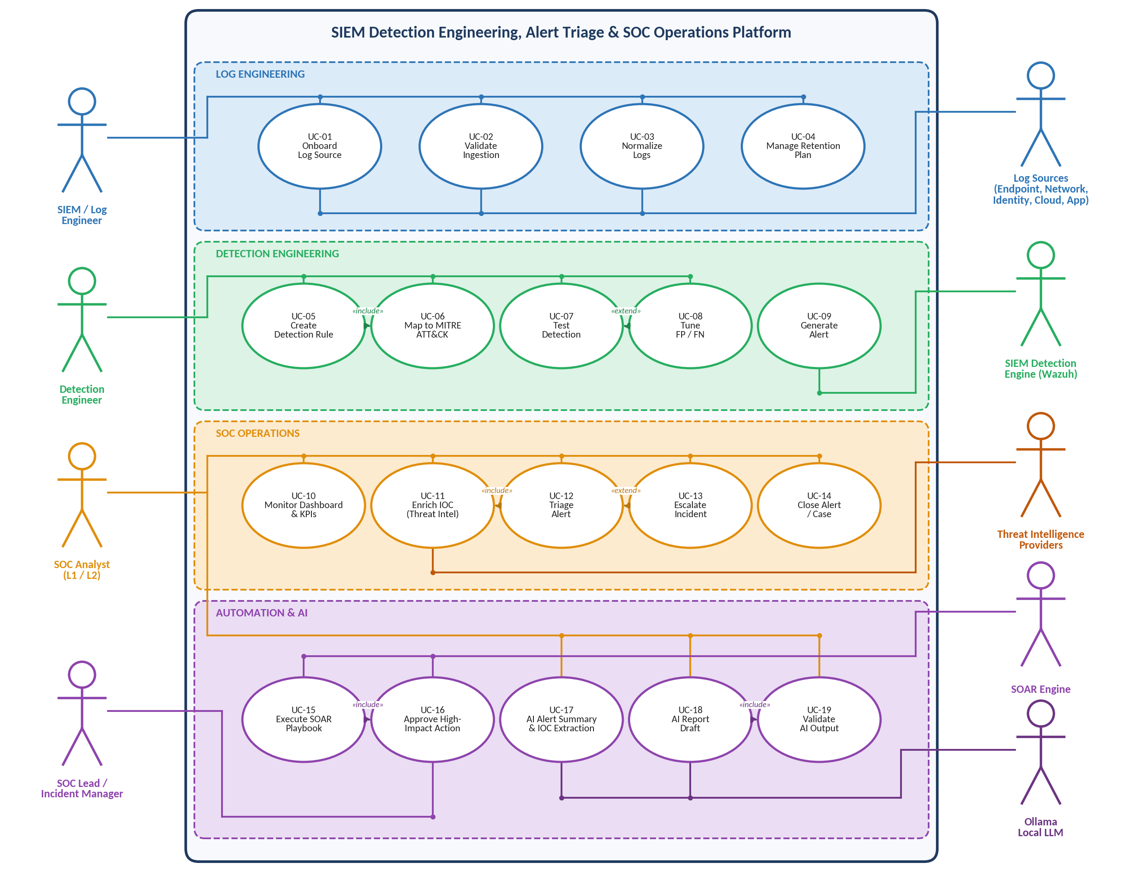
Figure 2.1 — Use case diagram: human actors (left), external/system actors (right), use cases grouped into four functional packages. Dashed arrows show «include» / «extend» relationships.

2.3 Use Case Descriptions
Four representative use cases (one per package) are described below; the remaining use cases follow the same format.
UC-07 — Test Detection
Primary actor | Detection Engineer
Secondary actors | Log Sources (simulated attack activity)
Description | Verify that a rule fires on simulated malicious activity and does not fire on normal activity.
Preconditions | Rule is Draft or Testing; test scenario and expected result are defined.
Main flow | 1. Engineer simulates activity (e.g., repeated failed SSH logins).  2. Logs are generated and received by the SIEM.  3. Rule executes; an alert is generated (UC-09).  4. Engineer compares expected and actual results and attaches evidence (logs, alert, rule configuration).  5. Test result is stored: Pass / Fail / Tuned.
Alternative flows | A1. No alert generated (false negative) → analyze cause and tune rule (UC-08 «extend»).
Postconditions | Test record with evidence is stored; rule status becomes Active when Pass.

UC-12 — Triage Alert
Primary actor | SOC Analyst
Description | Validate and classify an alert using the structured triage workflow.
Preconditions | Alert exists with status New.
Main flow | 1. Analyst opens the alert and validates it against raw logs.  2. Analyst collects context (user, host, time, related events).  3. Analyst investigates evidence and requests IOC enrichment (UC-11 «include»).  4. Analyst reviews asset criticality and user context.  5. Analyst determines severity and classification (True Positive / False Positive / Benign True Positive).  6. Analyst selects disposition: Escalate, Respond or Close.
Alternative flows | A1. Evidence insufficient → classification Undetermined; keep Monitoring. A2. Disposition Escalate → UC-13 «extend».
Postconditions | Triage record stored with evidence, severity, classification, disposition and timestamps.

UC-15 — Execute SOAR Playbook
Primary actor | SOAR Engine
Secondary actors | SOC Analyst, SOC Lead
Description | Run the phishing/malware playbook: enrichment, decision, containment, ticket, notification and escalation.
Preconditions | Playbook is Active and triggered by a matching alert.
Main flow | 1. Extract URL / domain / hash from the alert.  2. Query threat intelligence and determine reputation.  3. Decision point: malicious or benign (confidence threshold).  4. Malicious → create ticket, notify SOC, propose containment (block IOC); high-impact steps wait for approval (UC-16 «include»).  5. Benign → close or monitor.  6. Execution log is stored.
Alternative flows | A1. Approval denied → action skipped and logged. A2. Enrichment fails → route to analyst.
Postconditions | Playbook execution recorded with status and approver.

UC-17 — AI Alert Summary & IOC Extraction
Primary actor | SOC Analyst
Secondary actors | Ollama Local LLM
Description | Send relevant alert data to the local LLM to obtain a summary, key entities, suspicious indicators, timeline and recommended investigation steps.
Preconditions | Ollama is running locally; alert data is minimized (no unnecessary personal data).
Main flow | 1. Analyst selects an alert and a prompt template.  2. System sends the alert data with instructions: do not invent facts, state uncertainty.  3. LLM returns summary, entities, IOCs and investigation questions.  4. Output is stored as Pending validation.
Postconditions | AI output stored and linked to the alert; it is advisory only until UC-19.

3. Functional & Non-Functional Requirements
Requirements are derived from the project guideline (Weeks 1–4, technical standards and definition of done). Priority uses MoSCoW: Must = required for the Definition of Done, Should = important, Could = optional enhancement.

3.1 Functional Requirements
ID | Requirement | Priority
FR-01 | The system shall collect logs from Windows and Linux endpoints and web servers through Wazuh agents. | Must
FR-02 | The system shall ingest network, identity and cloud logs via syslog/API connectors or simulated datasets. | Must
FR-03 | The system shall allow verification that sources communicate, logs arrive, timestamps/hosts are correct and fields are searchable. | Must
FR-04 | The system shall normalize source-specific fields into a common model (e.g., src → source.ip, user → user.name, EventID → event.code). | Must
FR-05 | The system shall maintain a data-source inventory with status Implemented / Simulated / Planned. | Must
FR-06 | The system shall define retention periods and storage tiers (hot / warm / cold) per source type. | Must
FR-07 | The system shall support custom detection rules with threshold, time window, grouping fields and severity. | Must
FR-08 | The rule set shall cover brute force, suspicious login, lateral movement, persistence and data exfiltration (5–10 rules). | Must
FR-09 | Each rule shall be mapped to a MITRE ATT&CK technique/sub-technique supported by observed evidence. | Must
FR-10 | Each rule shall be documented with the detection template (objective, data sources, logic, FP, tuning, test). | Must
FR-11 | The system shall record each test: scenario, expected result, actual result, evidence and status. | Must
FR-12 | The system shall record false-positive/false-negative analysis and tuning notes per rule. | Must
FR-13 | The detection engine shall generate alerts containing rule, asset, user, source/destination, event time and detection time. | Must
FR-14 | The system shall provide an alert queue with search and filtering by severity, status, rule and asset. | Must
FR-15 | The system shall support the triage workflow: validate → context → investigate → threat intel → asset/user context → severity → classify → disposition. | Must
FR-16 | The system shall store a triage record with evidence, timeline, MITRE mapping, severity, classification, disposition and timestamps. | Must
FR-17 | The system shall extract and validate IOCs (IP, domain, URL, hash) from alerts. | Must
FR-18 | The system shall query threat-intelligence providers and store reputation, confidence and context. | Must
FR-19 | The system shall provide an escalation message template and record each escalation. | Must
FR-20 | The system shall support opening, assigning and closing cases linked to alerts. | Should
FR-21 | The dashboard shall show alert volume, MTTD, MTTR, closure rate, top attackers/sources and top targets. | Must
FR-22 | KPI calculations shall use documented timestamps (MTTD = detection time − event time; MTTR = resolution time − detection time). | Must
FR-23 | The system shall define playbooks as ordered actions with an automation level (Automatic / Conditional / Manual). | Must
FR-24 | The playbook shall automate low-risk actions: IOC extraction, threat-intel lookup, ticket creation and SOC notification. | Must
FR-25 | High-impact actions (block IOC, disable account, isolate server) shall require human approval. | Must
FR-26 | The system shall log every playbook execution, outcome and approver. | Should
FR-27 | The system shall use a locally hosted LLM (Ollama) to summarize alerts, list entities, indicators and a timeline. | Must
FR-28 | The LLM shall extract IOCs and propose investigation questions that the analyst validates against evidence. | Must
FR-29 | The LLM shall draft reports from validated findings. | Should
FR-30 | Every AI output shall be stored with prompt, model and validation status; unvalidated output shall not enter final reports. | Must
FR-31 | Prompts shall instruct the model not to invent facts and to state uncertainty. | Must
FR-32 | The system shall produce a MITRE ATT&CK coverage matrix (technique, detection, data source, rule, test status). | Must
FR-33 | The project shall produce a final SOC operations report with evidence captions for every task. | Must
FR-34 | The system shall enforce role-based access control for analysts, leads, engineers and administrators. | Should
FR-35 | The system shall keep an audit trail of analyst actions (triage, escalation, approvals, AI validation). | Should

3.2 Non-Functional Requirements
ID | Category | Requirement | Measure / acceptance criterion
NFR-01 | Performance | Events shall become searchable shortly after they occur. | End-to-end latency (event → searchable in dashboard) ≤ 60 s in the lab
NFR-02 | Performance | Alerts shall be produced quickly after the triggering event. | Alert generated ≤ 2 min after the rule threshold is met
NFR-03 | Reliability | Agents shall buffer events when the manager is unreachable; no log loss for onboarded sources. | 0 lost events in the validation test after a 5-minute manager outage
NFR-04 | Security | All component communication shall be encrypted and authenticated. | TLS between agents, manager, indexer, dashboard, API and DB; no default credentials
NFR-05 | Security | Access shall follow least privilege. | RBAC with at least 4 roles; API keys stored outside source code
NFR-06 | Privacy | The LLM shall run locally and receive only the minimum data needed. | No log data sent to external AI services; PII minimized in prompts
NFR-07 | Auditability | Security-relevant actions shall be traceable to a user and time. | 100 % of triage, escalation, approval and AI-validation actions logged
NFR-08 | Accuracy | Detection rules shall minimize false positives. | Each rule tuned; observed false-positive rate documented and reduced after tuning
NFR-09 | Interoperability | Components shall integrate through standard protocols. | Syslog, REST/JSON, Wazuh API, OpenSearch API, SQL
NFR-10 | Explainability | AI output shall be clearly labelled advisory and traceable. | Every AI output shows model, prompt, validation status and reviewer

3.3 Constraints & Assumptions

Constraints
- Open-source/free tooling only (Wazuh, PostgreSQL, Ollama, free threat-intel tiers).
- Lab hardware is limited, so cloud sources may be simulated with sample datasets and must be labelled Simulated.
- AI output is advisory and must be human-validated; high-impact automated actions require approval.

Assumptions
- The lab network allows agents to reach the Wazuh Manager and the analyst to reach the dashboard.
- Attack simulations are performed only on lab systems owned by the team.
- A local machine can run Ollama with a small/medium model (CPU or GPU).

4. Software Architecture

4.1 Architectural Style
The platform follows a layered, event-driven pipeline architecture built from loosely coupled, service-oriented components. Data flows in one direction — from data sources through collection, the SIEM core and SOC operations to response and intelligence services — while services communicate through agents, REST APIs and events. MVC is not the primary style because the system is a data-processing pipeline rather than a single interactive application; however, the SOC Operations API/Console follows an MVC-like separation internally (model = SOC database, view = analyst console/dashboard, controller = Operations API).
Style / pattern | Where it is applied | Benefit
Layered architecture | 5 layers: Data Sources → Collection → SIEM Core → SOC Operations → Response & Intelligence | Separation of concerns; each layer can be replaced or scaled independently
Pipe-and-filter (pipeline) | Collection → decoding/normalization → detection → alerting | Clear, testable stages; supports normalization and rule testing
Event-driven | Alert generation triggers triage, enrichment, SOAR playbooks and AI summarization | Near-real-time reaction; automation hooks
Service-oriented / micro-service style | Wazuh services, Operations API, SOAR engine, Ollama, threat-intel connectors | Loose coupling through REST APIs; independent deployment
Human-in-the-loop control | Approval gates in SOAR; validation gate for AI output | Safety for high-impact actions and AI errors

4.2 Architecture Diagram
Figure 4.1 (next page) shows the five layers and cross-cutting concerns.

Figure 4.1 — High-Level Software Architecture
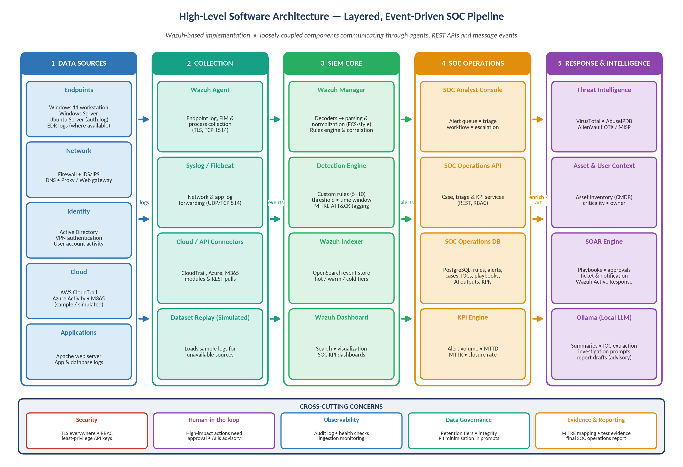
Figure 4.1 — Layered SOC architecture: logs flow left to right; alerts are enriched and acted upon by SOC operations, SOAR, threat intelligence and the local LLM.

4.3 Component Description
Layer | Component | Responsibility | Technology | Status
1 Data Sources | Endpoints | Windows 11 / Server and Ubuntu generate security, process and authentication logs | Windows Event Log, Sysmon, auth.log | Implemented
1 Data Sources | Network / Identity / Cloud / Apps | Firewall, IDS, DNS, proxy, Active Directory, VPN, CloudTrail, Azure, M365, Apache, DB | Syslog, JSON, APIs | Apache implemented; others Planned/Simulated
2 Collection | Wazuh Agent | Collects logs, file integrity and process data; forwards over TLS with buffering | Wazuh agent (TCP 1514) | Implemented
2 Collection | Syslog / Filebeat | Forwards network and application logs | Syslog UDP/TCP 514, Filebeat | Planned
2 Collection | Cloud / API connectors | Pull CloudTrail, Azure and M365 events | Wazuh modules, REST | Simulated
2 Collection | Dataset replay | Replays sample logs for unavailable sources | Python / logger scripts | Simulated
3 SIEM Core | Wazuh Manager | Decodes and normalizes events; runs rules and correlation; active response | Wazuh decoders & rules (XML) | Implemented
3 SIEM Core | Detection Engine | Custom rules for the 5–10 use cases, MITRE tagging | Wazuh rules, frequency/timeframe | Implemented
3 SIEM Core | Wazuh Indexer | Stores and indexes events and alerts; hot/warm/cold lifecycle | OpenSearch-based indexer | Implemented
3 SIEM Core | Wazuh Dashboard | Search, visualization, SOC KPI dashboards | Wazuh dashboard | Implemented
4 SOC Operations | SOC Analyst Console | Alert queue, triage forms, escalation | Dashboard + web UI | Implemented
4 SOC Operations | SOC Operations API | Case, triage, IOC, rule-catalog and KPI services; RBAC | REST (Python/FastAPI or Node) | Designed
4 SOC Operations | SOC Operations DB | Relational store for operational data (Section 5) | PostgreSQL | Designed
4 SOC Operations | KPI Engine | Computes alert volume, MTTD, MTTR, closure rate | SQL views + dashboard | Designed
5 Response & Intelligence | Threat Intelligence | IP/domain/URL/hash reputation | VirusTotal, AbuseIPDB, OTX/MISP | Implemented (free tiers)
5 Response & Intelligence | Asset & User Context | Criticality, owner, OS of assets | assets table / CMDB export | Designed
5 Response & Intelligence | SOAR Engine | Playbooks, approvals, ticket/notification, active response | Shuffle / n8n / Python + Wazuh AR | Designed
5 Response & Intelligence | Ollama (Local LLM) | Summaries, IOC extraction, questions, report drafts | Ollama + open-weight model | Implemented

4.4 Component Interactions
From → To | Interface | Data exchanged
Wazuh Agent → Wazuh Manager | TLS over TCP 1514 | Events, file-integrity and process data
Network / App sources → Wazuh Manager | Syslog (514) | Firewall, DNS, proxy, application logs
Wazuh Manager → Wazuh Indexer | HTTPS REST | Normalized events and alerts
Operations API → SOC Database | SQL over TLS (5432) | Alerts, triage, cases, IOCs, KPIs
Operations API → Threat Intelligence | HTTPS REST (API key) | IOC lookups and reputation
Operations API ↔ SOAR Engine | Webhook / REST | Alert trigger, playbook status, approvals
Operations API → Ollama | HTTP (localhost:11434) | Minimized alert data in, summary/draft out

5. Database Design & Data Modeling
The SOC Operations Database (PostgreSQL) stores the structured data created and updated by the SOC: detection rules, MITRE mapping, alerts, triage, cases, IOCs, SOAR playbooks and AI outputs. Raw log events stay in the Wazuh Indexer and are linked to the database through alerts.siem_alert_id.

5.1 Entity-Relationship Diagram
Figure 5.1 (next page) shows the 23 entities grouped in seven functional domains with crow's-foot cardinalitie

Figure 5.1 — ERD of the SOC Operations Database
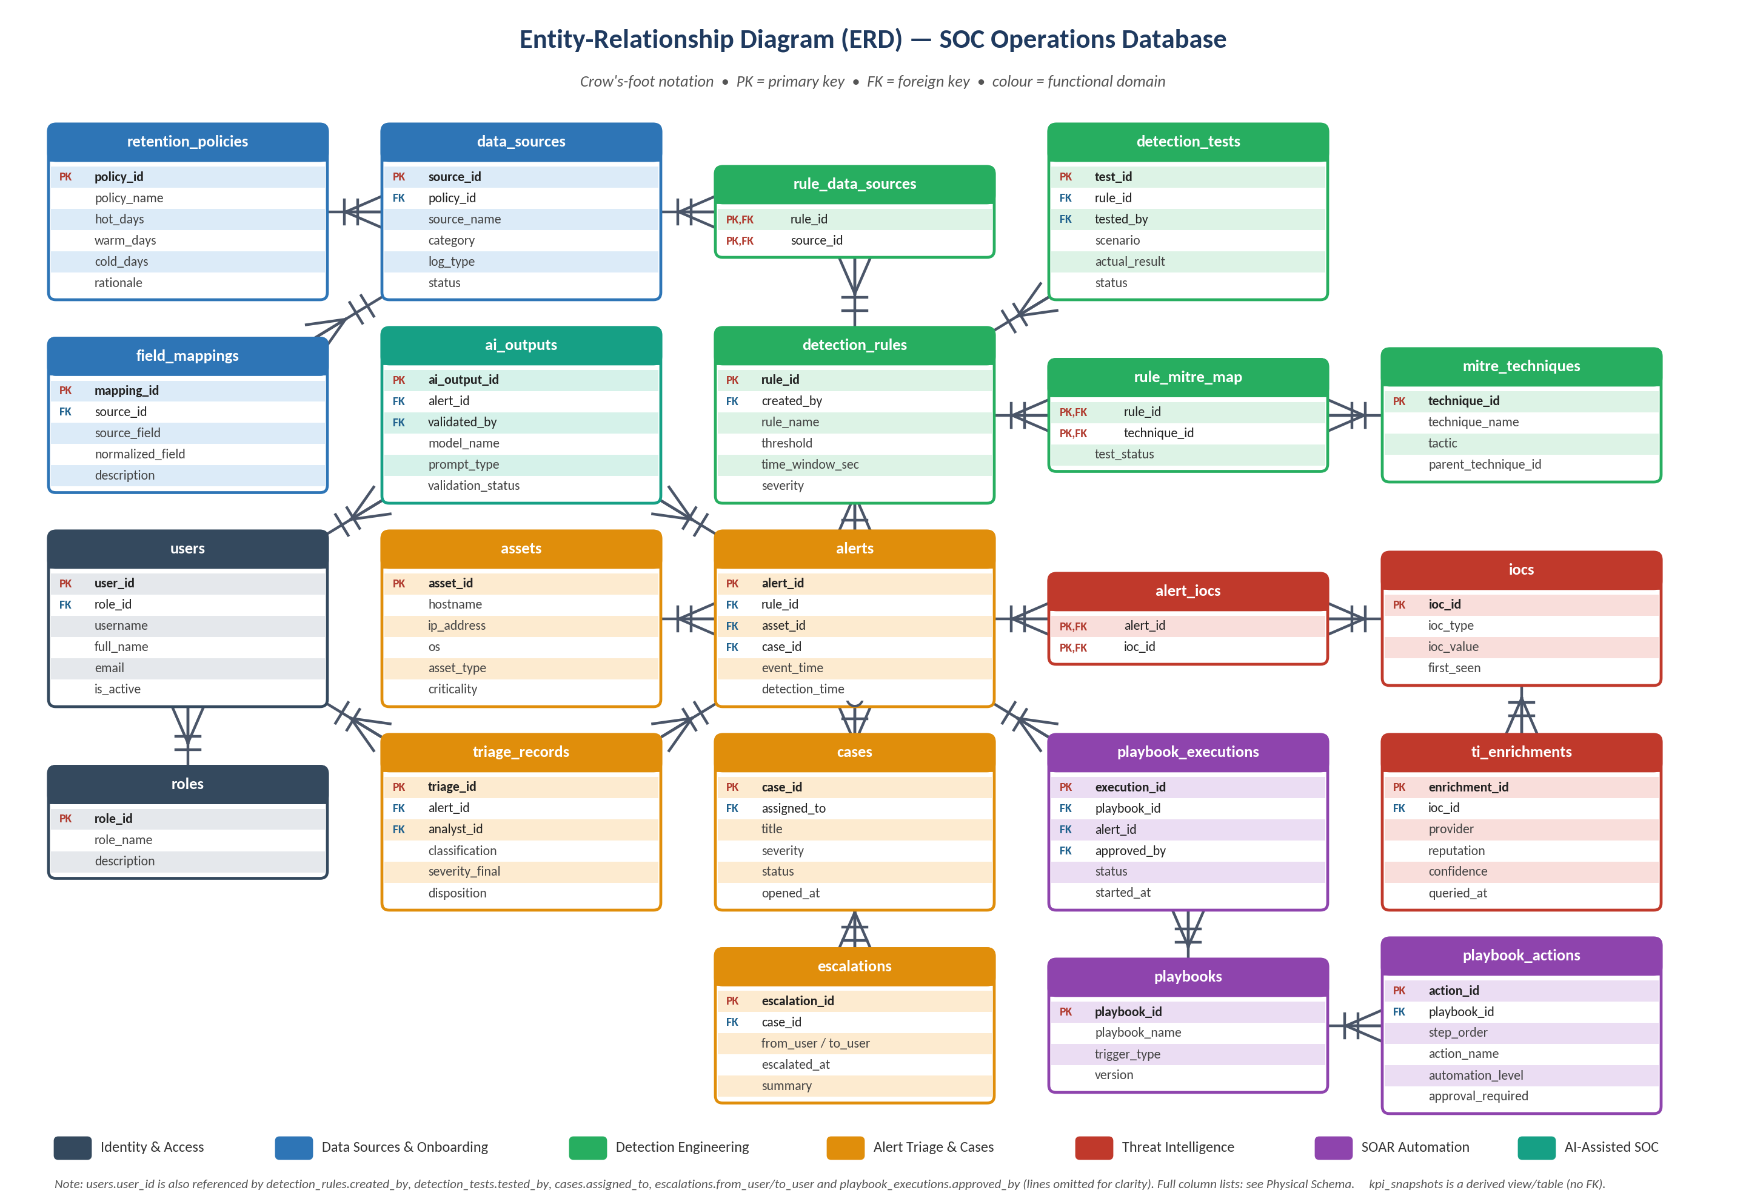
Figure 5.1 — Entity-Relationship Diagram (PK = primary key, FK = foreign key). Junction tables rule_data_sources, rule_mitre_map and alert_iocs resolve many-to-many relationships.

5.2 Relationships & Cardinality
Parent (1) | Child (N) | Cardinality | Foreign key | Business meaning
roles | users | 1 : N | users.role_id | A role is assigned to many users
retention_policies | data_sources | 1 : N | data_sources.policy_id | A policy governs many sources
data_sources | field_mappings | 1 : N | field_mappings.source_id | A source has many field mappings
detection_rules ↔ data_sources | rule_data_sources | M : N | rule_id, source_id | A rule uses several sources; a source feeds several rules
detection_rules ↔ mitre_techniques | rule_mitre_map | M : N | rule_id, technique_id | A rule maps to techniques; a technique is covered by rules
detection_rules | detection_tests | 1 : N | detection_tests.rule_id | A rule is tested repeatedly (re-tests after tuning)
detection_rules | alerts | 1 : N | alerts.rule_id | A rule generates many alerts
assets | alerts | 1 : N | alerts.asset_id | An asset is the target of many alerts
cases | alerts | 1 : 0..N | alerts.case_id (nullable) | A case groups related alerts; most alerts never become cases
alerts | triage_records | 1 : N | triage_records.alert_id | An alert may be re-triaged; one record is final
users | triage_records | 1 : N | triage_records.analyst_id | An analyst triages many alerts
cases | escalations | 1 : N | escalations.case_id | A case can be escalated several times
alerts ↔ iocs | alert_iocs | M : N | alert_id, ioc_id | An alert contains several IOCs; an IOC appears in many alerts
iocs | ti_enrichments | 1 : N | ti_enrichments.ioc_id | An IOC is checked by several providers/times
playbooks | playbook_actions | 1 : N | playbook_actions.playbook_id | A playbook has ordered steps
playbooks / alerts | playbook_executions | 1 : N each | playbook_id, alert_id | A playbook runs for many alerts; an alert may trigger runs
alerts | ai_outputs | 1 : N | ai_outputs.alert_id | Several AI outputs per alert (summary, questions, draft)
users | ai_outputs / cases / escalations / playbook_executions | 1 : N | validated_by, assigned_to, from/to_user, approved_by | Accountability of human actions

5.3 Logical Schema
The logical schema lists every relation with its primary key (in bold), foreign keys (→) and main attributes, independent of the DBMS.
Relation | Schema (bold = primary key, → = foreign key)
roles | (role_id, role_name, description)
users | (user_id, role_id → roles, username, full_name, email, password_hash, is_active, created_at)
retention_policies | (policy_id, policy_name, hot_days, warm_days, cold_days, rationale)
data_sources | (source_id, policy_id → retention_policies, source_name, category, log_type, collection_method, security_value, status)
field_mappings | (mapping_id, source_id → data_sources, source_field, normalized_field, description)
mitre_techniques | (technique_id, technique_name, tactic, parent_technique_id → mitre_techniques)
detection_rules | (rule_id, rule_code, wazuh_rule_id, rule_name, objective, detection_logic, threshold, time_window_sec, severity, status, expected_false_positives, tuning_strategy, version, created_by → users, created_at, updated_at)
rule_data_sources | (rule_id → detection_rules, source_id → data_sources)
rule_mitre_map | (rule_id → detection_rules, technique_id → mitre_techniques, test_status)
detection_tests | (test_id, rule_id → detection_rules, tested_by → users, scenario, expected_result, actual_result, status, evidence_path, tested_at)
assets | (asset_id, hostname, ip_address, os, asset_type, criticality, owner, wazuh_agent_id)
cases | (case_id, case_code, title, severity, status, summary, potential_impact, assigned_to → users, opened_at, closed_at)
alerts | (alert_id, siem_alert_id, rule_id → detection_rules, asset_id → assets, case_id → cases, affected_user, source_ip, destination_ip, event_time, detection_time, severity, status)
triage_records | (triage_id, alert_id → alerts, analyst_id → users, initial_assessment, evidence, severity_final, classification, disposition, recommended_action, is_final, started_at, resolved_at)
escalations | (escalation_id, case_id → cases, from_user → users, to_user → users, summary, actions_taken, next_steps, escalated_at, acknowledged_at)
iocs | (ioc_id, ioc_type, ioc_value, is_valid, first_seen)
alert_iocs | (alert_id → alerts, ioc_id → iocs)
ti_enrichments | (enrichment_id, ioc_id → iocs, provider, reputation, confidence, raw_summary, queried_at)
playbooks | (playbook_id, playbook_name, trigger_type, description, version, is_active)
playbook_actions | (action_id, playbook_id → playbooks, step_order, action_name, automation_level, approval_required)
playbook_executions | (execution_id, playbook_id → playbooks, alert_id → alerts, approved_by → users, status, execution_log, started_at, ended_at)
ai_outputs | (ai_output_id, alert_id → alerts, validated_by → users, model_name, prompt_type, prompt_text, output_text, validation_status, validation_notes, created_at, validated_at)

5.4 Physical Schema (PostgreSQL)
The physical schema defines data types, keys and constraints for each table. Tables are grouped by functional domain using the same colours as the ERD.
Identity & Access | Columns — data type — constraints
roles  System roles used for access control. | role_id SMALLINT PK • role_name VARCHAR(40) UNIQUE, NOT NULL • description TEXT
users  People who use the platform. | user_id SERIAL PK • role_id SMALLINT FK → roles, NOT NULL • username VARCHAR(50) UNIQUE, NOT NULL • full_name VARCHAR(100) NOT NULL • email VARCHAR(120) UNIQUE, NOT NULL • password_hash VARCHAR(255) NOT NULL • is_active BOOLEAN DEFAULT TRUE • created_at TIMESTAMPTZ DEFAULT now()

Data Sources & Onboarding | Columns — data type — constraints
retention_policies  Retention periods and storage tiers. | policy_id SERIAL PK • policy_name VARCHAR(60) UNIQUE, NOT NULL • hot_days INT CHECK ≥ 0 • warm_days INT CHECK ≥ 0 • cold_days INT CHECK ≥ 0 • rationale TEXT
data_sources  Data-source inventory (Task 1.2). | source_id SERIAL PK • policy_id INT FK → retention_policies • source_name VARCHAR(100) UNIQUE, NOT NULL • category VARCHAR(20) CHECK IN (Endpoint, Network, Identity, Cloud, Application) • log_type VARCHAR(60) NOT NULL • collection_method VARCHAR(40) • security_value TEXT • status VARCHAR(12) CHECK IN (Implemented, Simulated, Planned)
field_mappings  Normalized field mapping (Task 1.5). | mapping_id SERIAL PK • source_id INT FK → data_sources, NOT NULL • source_field VARCHAR(80) NOT NULL • normalized_field VARCHAR(80) NOT NULL • description TEXT • [UNIQUE (source_id, source_field)]

Detection Engineering | Columns — data type — constraints
mitre_techniques  MITRE ATT&CK technique reference. | technique_id VARCHAR(12) PK • technique_name VARCHAR(120) NOT NULL • tactic VARCHAR(60) NOT NULL • parent_technique_id VARCHAR(12) FK → mitre_techniques (self), NULL
detection_rules  Detection rule catalog (Task 2.6 template). | rule_id SERIAL PK • rule_code VARCHAR(30) UNIQUE, NOT NULL • wazuh_rule_id INT UNIQUE • rule_name VARCHAR(120) NOT NULL • objective TEXT • detection_logic TEXT NOT NULL • threshold INT CHECK > 0 • time_window_sec INT CHECK > 0 • severity VARCHAR(10) CHECK IN (Low, Medium, High, Critical) • status VARCHAR(10) CHECK IN (Draft, Testing, Active, Retired) • expected_false_positives TEXT • tuning_strategy TEXT • version INT DEFAULT 1 • created_by INT FK → users • created_at / updated_at TIMESTAMPTZ DEFAULT now()
rule_data_sources  Junction: rules ↔ data sources (M:N). | rule_id INT PK, FK → detection_rules • source_id INT PK, FK → data_sources
rule_mitre_map  Junction: rules ↔ MITRE techniques; coverage map (Task 4.3). | rule_id INT PK, FK → detection_rules • technique_id VARCHAR(12) PK, FK → mitre_techniques • test_status VARCHAR(12) CHECK IN (Tested, Partial, Not tested)
detection_tests  Detection test evidence (Task 2.7). | test_id SERIAL PK • rule_id INT FK → detection_rules, NOT NULL • tested_by INT FK → users • scenario TEXT NOT NULL • expected_result TEXT • actual_result TEXT • status VARCHAR(10) CHECK IN (Pass, Fail, Tuned) • evidence_path VARCHAR(255) • tested_at TIMESTAMPTZ DEFAULT now()

Alert Triage & Cases | Columns — data type — constraints
assets  Asset context (criticality, owner). | asset_id SERIAL PK • hostname VARCHAR(100) UNIQUE, NOT NULL • ip_address INET • os VARCHAR(60) • asset_type VARCHAR(20) CHECK IN (Workstation, Server, Network Device, Cloud Resource) • criticality VARCHAR(10) CHECK IN (Low, Medium, High, Critical) • owner VARCHAR(100) • wazuh_agent_id VARCHAR(10) UNIQUE
cases  Incident cases created on escalation. | case_id SERIAL PK • case_code VARCHAR(20) UNIQUE, NOT NULL • title VARCHAR(200) NOT NULL • severity VARCHAR(10) CHECK IN (Low, Medium, High, Critical) • status VARCHAR(15) CHECK IN (Open, Investigating, Contained, Closed) • summary TEXT • potential_impact TEXT • assigned_to INT FK → users • opened_at TIMESTAMPTZ DEFAULT now() • closed_at TIMESTAMPTZ NULL
alerts  Alerts generated by detection rules (synchronized from the SIEM). | alert_id BIGSERIAL PK • siem_alert_id VARCHAR(64) UNIQUE, NOT NULL • rule_id INT FK → detection_rules, NOT NULL • asset_id INT FK → assets • case_id INT FK → cases, NULL • affected_user VARCHAR(100) • source_ip INET • destination_ip INET • event_time TIMESTAMPTZ NOT NULL • detection_time TIMESTAMPTZ NOT NULL, CHECK ≥ event_time • severity VARCHAR(10) CHECK IN (Low, Medium, High, Critical) • status VARCHAR(16) CHECK IN (New, Triaging, False Positive, Escalated, Contained, True Positive Resolved, Closed)
triage_records  Analyst triage result (Task 3.4). | triage_id SERIAL PK • alert_id BIGINT FK → alerts, NOT NULL • analyst_id INT FK → users, NOT NULL • initial_assessment TEXT • evidence TEXT • severity_final VARCHAR(10) CHECK IN (Low, Medium, High, Critical) • classification VARCHAR(25) CHECK IN (True Positive, False Positive, Benign True Positive, Undetermined) • disposition VARCHAR(20) CHECK IN (Escalated, Resolved, Closed, Monitor) • recommended_action TEXT • is_final BOOLEAN DEFAULT FALSE • started_at / resolved_at TIMESTAMPTZ resolved_at NULL
escalations  Escalation communications (Task 3.6). | escalation_id SERIAL PK • case_id INT FK → cases, NOT NULL • from_user INT FK → users, NOT NULL • to_user INT FK → users, NOT NULL • summary TEXT NOT NULL • actions_taken TEXT • next_steps TEXT • escalated_at TIMESTAMPTZ DEFAULT now() • acknowledged_at TIMESTAMPTZ NULL

Threat Intelligence | Columns — data type — constraints
iocs  Indicators of compromise. | ioc_id SERIAL PK • ioc_type VARCHAR(12) CHECK IN (ip, domain, url, file_hash, email) • ioc_value VARCHAR(512) NOT NULL • is_valid BOOLEAN DEFAULT TRUE • first_seen TIMESTAMPTZ DEFAULT now() • [UNIQUE (ioc_type, ioc_value)]
alert_iocs  Junction: alerts ↔ IOCs (M:N). | alert_id BIGINT PK, FK → alerts • ioc_id INT PK, FK → iocs
ti_enrichments  Threat-intelligence results per IOC (Task 3.5 / 4.1). | enrichment_id SERIAL PK • ioc_id INT FK → iocs, NOT NULL • provider VARCHAR(40) NOT NULL • reputation VARCHAR(12) CHECK IN (Malicious, Suspicious, Clean, Unknown) • confidence SMALLINT CHECK 0–100 • raw_summary JSONB • queried_at TIMESTAMPTZ DEFAULT now()

SOAR Automation | Columns — data type — constraints
playbooks  SOAR playbook definitions (Task 4.4). | playbook_id SERIAL PK • playbook_name VARCHAR(100) UNIQUE, NOT NULL • trigger_type VARCHAR(40) NOT NULL • description TEXT • version INT DEFAULT 1 • is_active BOOLEAN DEFAULT TRUE
playbook_actions  Playbook steps and automation level (Task 4.5). | action_id SERIAL PK • playbook_id INT FK → playbooks, NOT NULL • step_order INT NOT NULL • action_name VARCHAR(100) NOT NULL • automation_level VARCHAR(12) CHECK IN (Automatic, Conditional, Manual) • approval_required BOOLEAN DEFAULT FALSE • [UNIQUE (playbook_id, step_order)]
playbook_executions  Runs of a playbook for an alert. | execution_id BIGSERIAL PK • playbook_id INT FK → playbooks, NOT NULL • alert_id BIGINT FK → alerts, NOT NULL • approved_by INT FK → users, NULL • status VARCHAR(18) CHECK IN (Running, Awaiting Approval, Completed, Failed, Cancelled) • execution_log JSONB • started_at / ended_at TIMESTAMPTZ ended_at NULL

AI-Assisted SOC | Columns — data type — constraints
ai_outputs  Local-LLM outputs and human validation (Tasks 4.6–4.9). | ai_output_id BIGSERIAL PK • alert_id BIGINT FK → alerts, NOT NULL • validated_by INT FK → users, NULL • model_name VARCHAR(60) NOT NULL • prompt_type VARCHAR(25) CHECK IN (Summary, Investigation Questions, IOC Extraction, Report Draft) • prompt_text TEXT NOT NULL • output_text TEXT NOT NULL • validation_status VARCHAR(10) CHECK IN (Pending, Accepted, Corrected, Rejected), DEFAULT Pending • validation_notes TEXT • created_at / validated_at TIMESTAMPTZ validated_at NULL

5.5 Normalization
Normal form | How the design satisfies it
1NF | Atomic columns only; lists (IOCs of an alert, techniques of a rule) are rows in junction tables (alert_iocs, rule_mitre_map), not comma-separated values.
2NF | Composite-key tables contain only attributes that depend on the whole key (e.g., test_status depends on rule + technique).
3NF | Reference data (roles, retention_policies, mitre_techniques, assets) is stored once and referenced by FK; no transitive dependencies.
Controlled denormalization | alerts keeps source_ip, destination_ip and affected_user for fast triage queries; MTTD/MTTR are computed in views, not stored.

